**Riphah international university**   
**BSAI**

**Lab Report**

**Title of the Lab Task:**

Lab # 5

Week # 5

**Course Name:**

**COAL**

**Submitted by:**

**Name:** Muneeb Nawaz

**Sap ID:** 66134

**Semester:** 3th Semester]

**Date of Submission:**

**9/22/2025**

**Lab task # 1**

**dosseg**

**.model small**

**.stack 100h**

**.data**

**.code**

**main proc**

**mov ah,1**

**int 21h**

**mov bl,al**

**mov ah,1**

**int 21h**

**add bl,al**

**sub bl,48**

**mov dl,bl**

**mov ah,2**

**int 21h**

**mov ah,4ch**

**int 21h**

**main endp**

**end main**

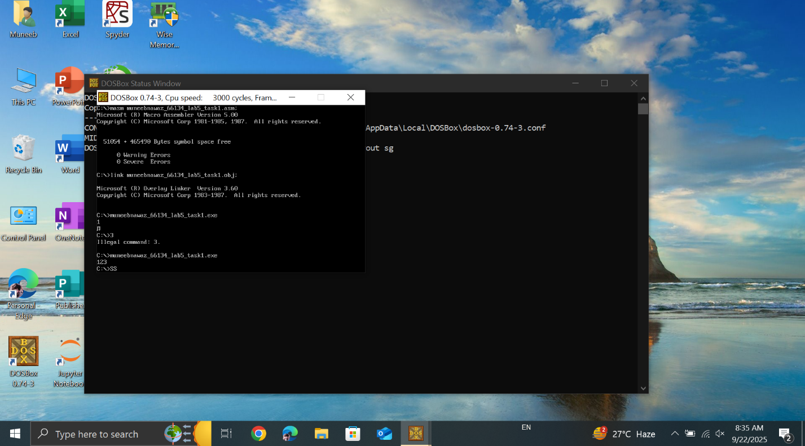

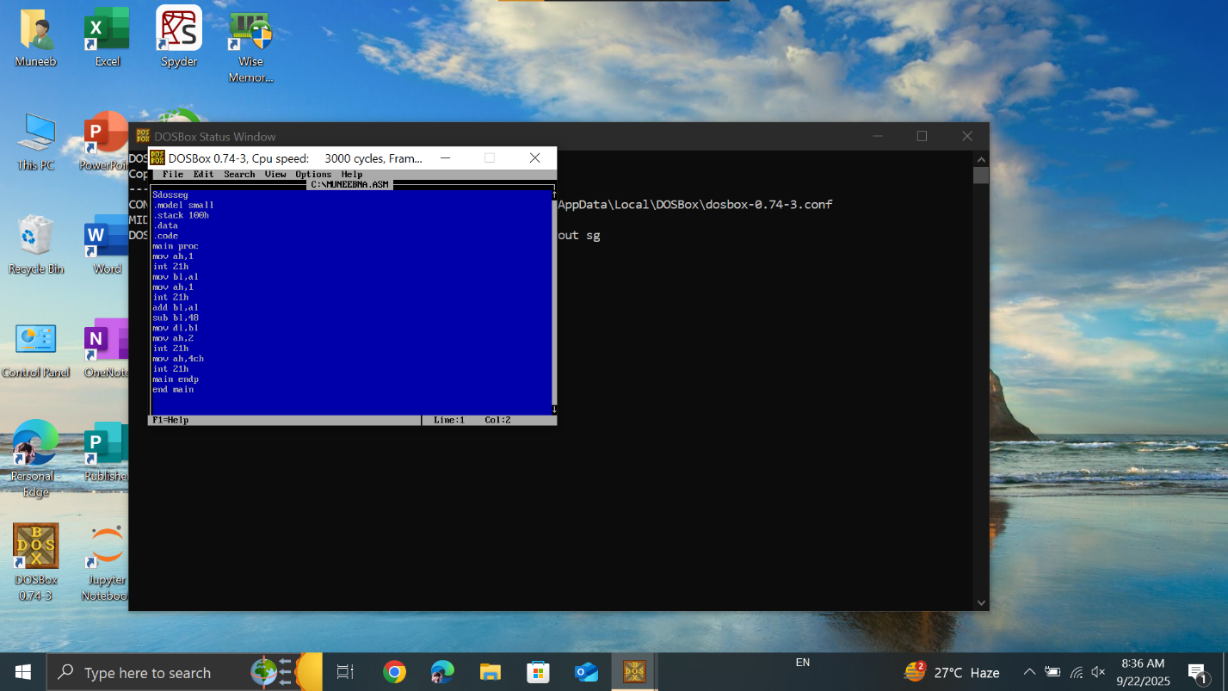

**Lab task # 2**

**model sma11**

**stack 100h**

**data**

**msg db?**

**.code**

**main proc**

**mov ah, 1**

**int 21h**

**mov bl, al**

**mov ah, 1**

**int 21h**

**mov bh, al**

**mov ah, 1**

**int 21h**

**mov cl, al**

**add bl, bh**

**sub bl, 48**

**mov ch, bl**

**add ch, cl**

**sub ch, 48**

**mov msg, ch**

**mov dl, msg**

**int 21h**

**mov ah, 4ch**

**int 21h**

**main endp**

**end main**

**output**

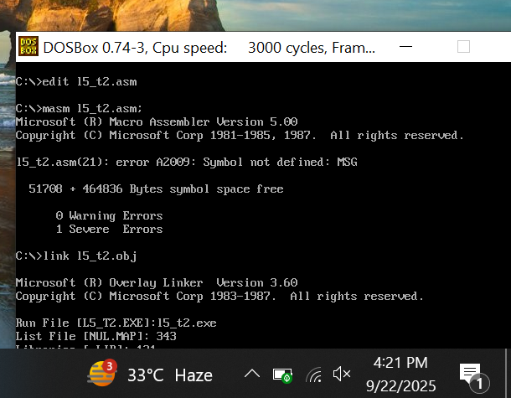

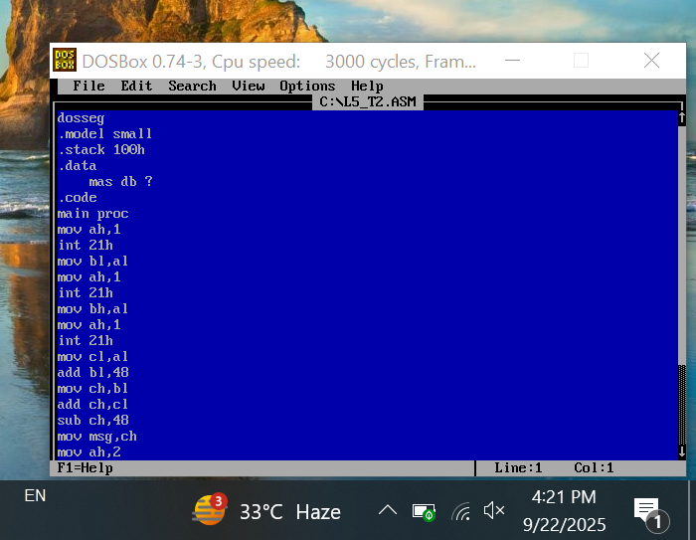

**Lab task # 3**

**Code**

**org 100h**

**mov ax,1h**

**mov bx,1h**

**mov cx,4h**

**JMP abc**

**add cx,bx**

**abc:**

**add cx,ax**

**ret**

**Output**

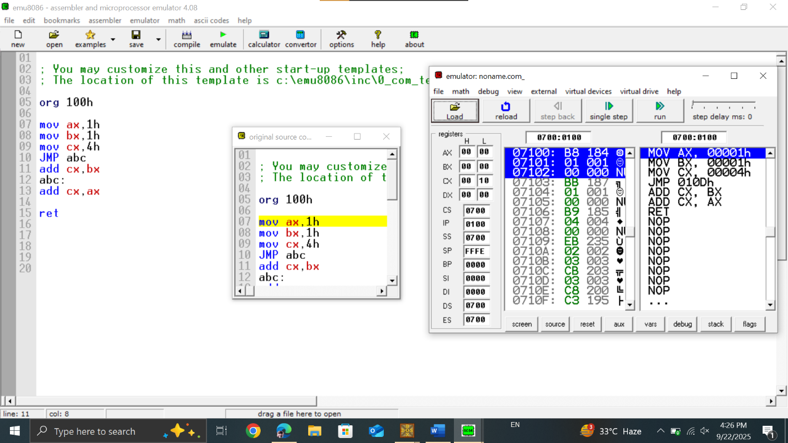

**Lab task # 4**

**Code**

**org 100h**

**mov ax,5**

**mov bx,3**

**add ax,bx**

**jmp last**

**mid:**

**mov ax,1**

**mov bx,2**

**add ax,bx**

**jmp final**

**last:**

**mov ax,3**

**mov bx,3**

**add ax,bx**

**jmp mid**

**final:**

**ret**

**Output**

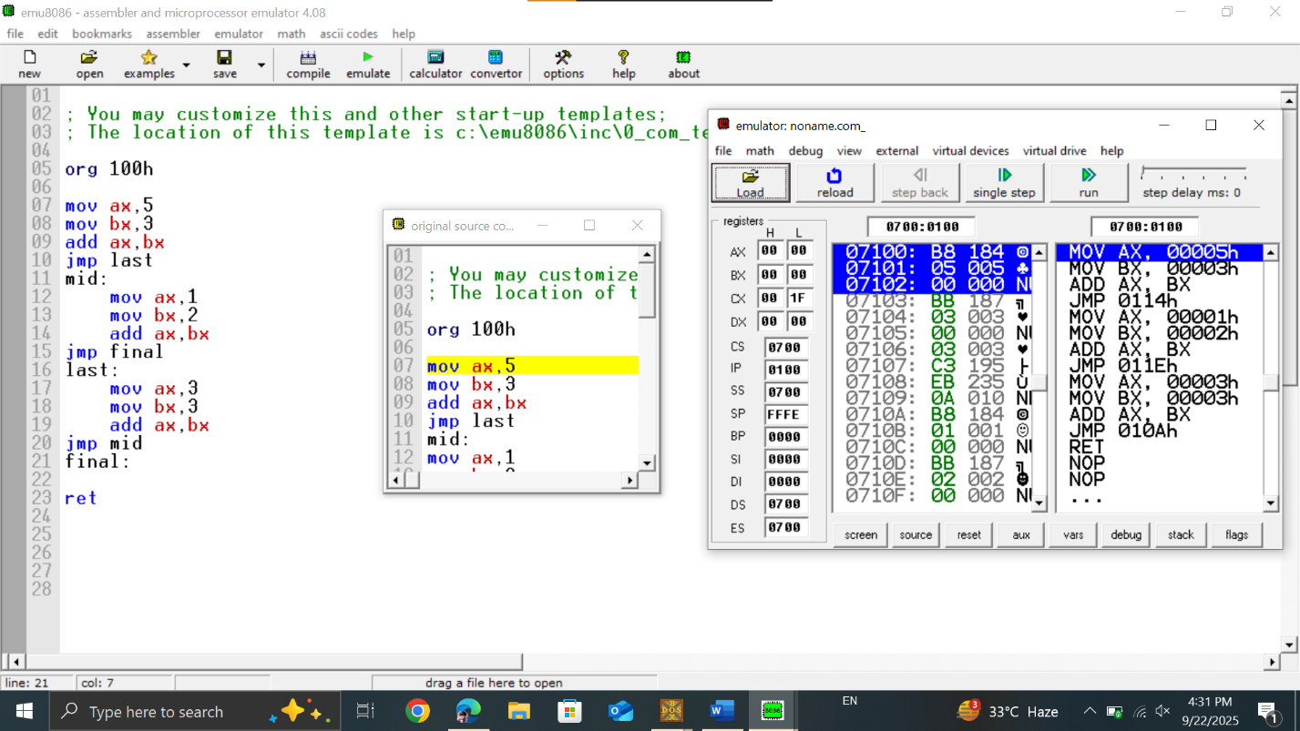

**Lab task # 5**

**Code**

**include 'emu8086.inc'**

**.model small**

**.stack 100h**

**.data**

**.code**

**main proc**

**mov dl,5**

**mov bl,5**

**cmp dl,bl**

**je move**

**print 'both not are equal'**

**mov ah,04h**

**int 21h**

**move:**

**print 'both are equal'**

**mov ah,04h**

**int 21h**

**main endp**

**end main**

**Output**

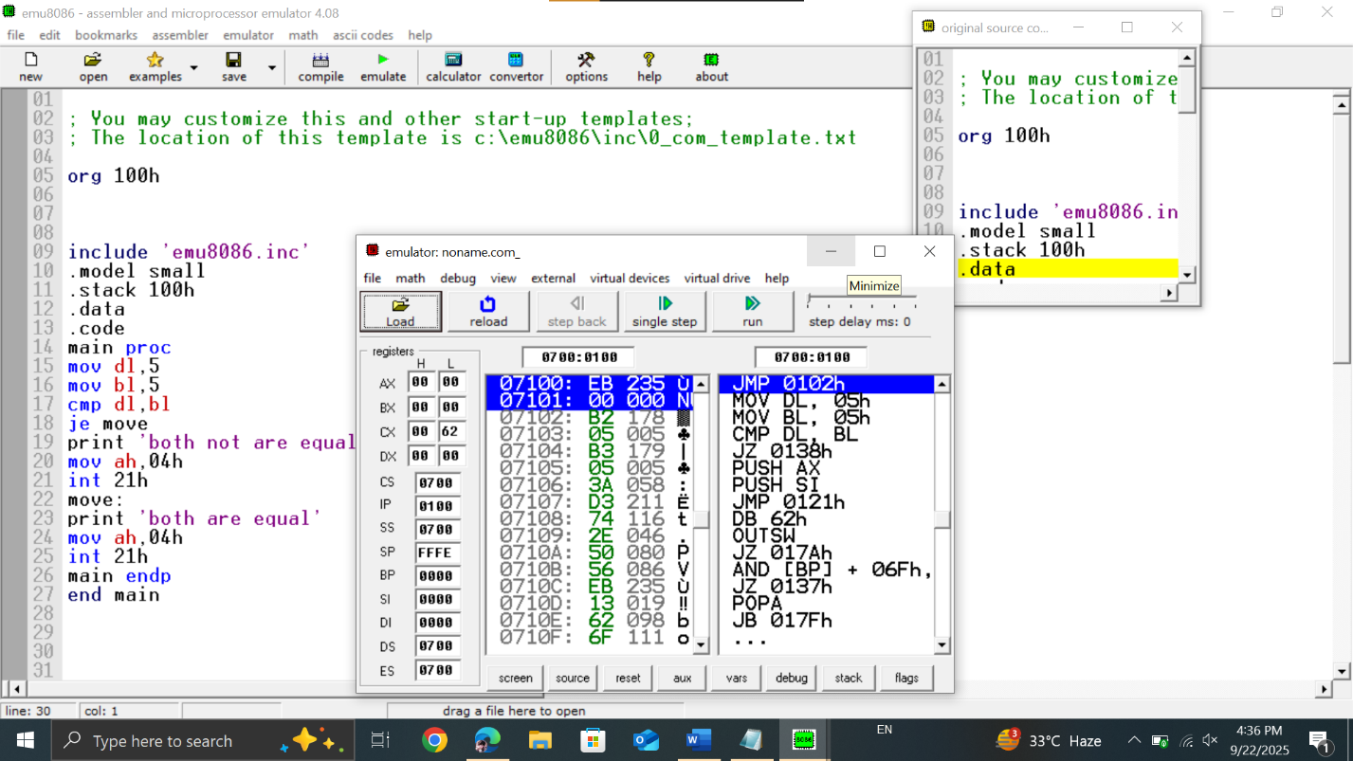

**Lab task # 6**

**Code**

**dosseg**

**.model small**

**.stack 100h**

**.data**

**msg1 db 'Number is equal$', 0**

**msg2 db 'Number is not equal$', 0**

**.code**

**main proc**

**mov ax, @data**

**mov ds, ax**

**mov ah, 1**

**int 21h**

**mov bl, al**

**mov dl, '3'**

**cmp bl, dl**

**je equal**

**mov dx, offset msg2**

**mov ah, 9**

**int 21h**

**jmp exit**

**equal:**

**mov dx, offset msg1**

**mov ah, 9**

**int 21h**

**exit:**

**mov ah, 4Ch**

**int 21h**

**main endp**

**end main**

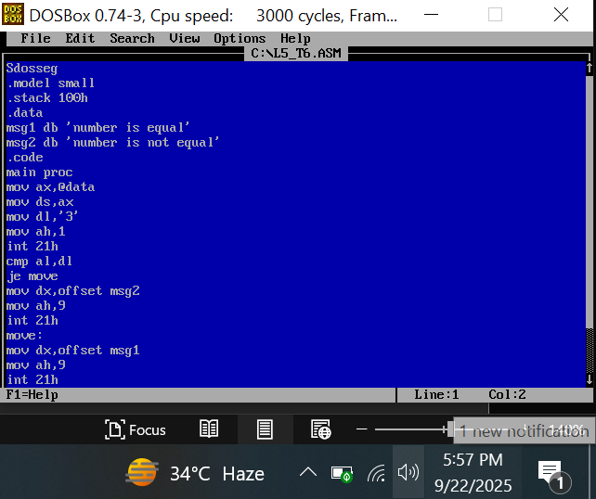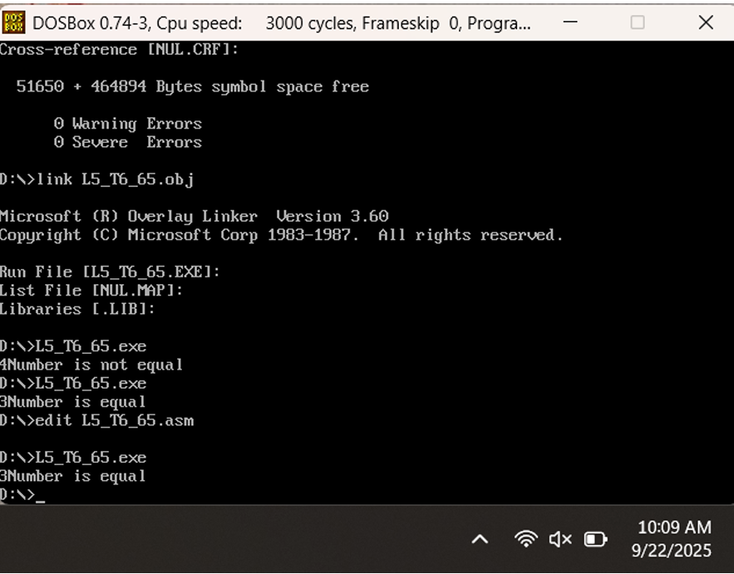

**Lab task # 7**

**include 'emu8086.inc'**

**.model small**

**.stack 100h**

**.data**

**.code**

**main proc**

**mov dl,5**

**mov bl,5**

**cmp dl,bl**

**je move**

**print 'both not are equal'**

**mov ah,04h**

**int 21h**

**move:**

**print 'both are equal'**

**mov ah,04h**

**int 21h**

**main endp**

**end main**

**Output**

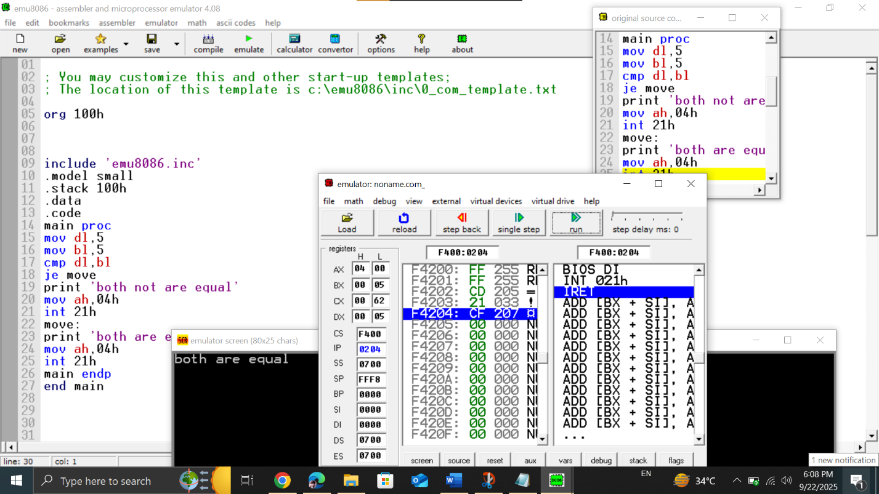

**Lab task # 8**

**; You may customize this and other start-up templates;**

**; The location of this template is c:\emu8086\inc\0_com_template.txt**

**org 100h**

**mov ax,6**

**cmp ax,5**

**js exit**

**mov ax,1**

**exit:**

**mov ax,0x4c00**

**int 0x21**

**mov ax,4h**

**mov bx,3h**

**cmp ax,bx**

**hlt**

**abc:**

**mov cx,ax**

**hlt**

**ret**

**Output**

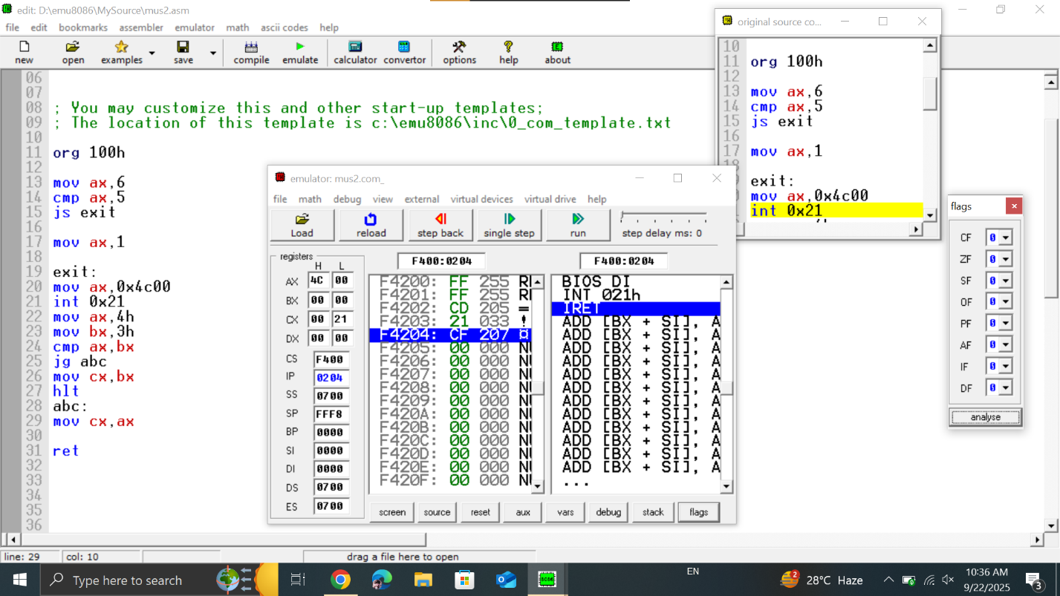

**Lab task # 9**

**; You may customize this and other start-up templates;**

**; The location of this template is c:\emu8086\inc\0_com_template.txt**

**org 100h ; Program entry point for .COM file (starts at offset 100h)**

**mov ax, 3 ; Load AX with value 3**

**cmp ax, 6 ; Compare AX with 6**

**js add ; Jump to label 'add' if result is negative (signed < 0)**

**jns exit ; Jump to label 'exit' if result is not negative (signed >= 0)**

**add:**

**mov ax, 2 ; If condition met, load AX with 2**

**exit:**

**mov ax, 4C00h ; DOS terminate program function**

**int 21h ; Call DOS interrupt to exit**

**ret**

**Output**

